**Final Project Report Template**

1. Introduction

**Objective**: Develop a deep learning model to classify the water levels in water bottles from images.

This can be useful for monitoring hydration levels, especially in smart health and fitness applications.

**Goals**:

* Accurately classify water levels in different types of bottles.
* Develop a robust and efficient model that can be deployed on mobile devices.
* Ensure the model can generalize well to various lighting conditions and bottle types.

2. Project Initialization and Planning Phase

* Define Problem Statement

With the increasing variety of water bottles available in the market, it has become challenging for consumers to quickly identify and choose the right product based on their preferences and requirements. The goal of this project is to develop an AI/ML model that can accurately classify images of water bottles into predefined categories, such as material type (plastic, metal, glass), size (small, medium, large), and specific features (insulated, non-insulated).

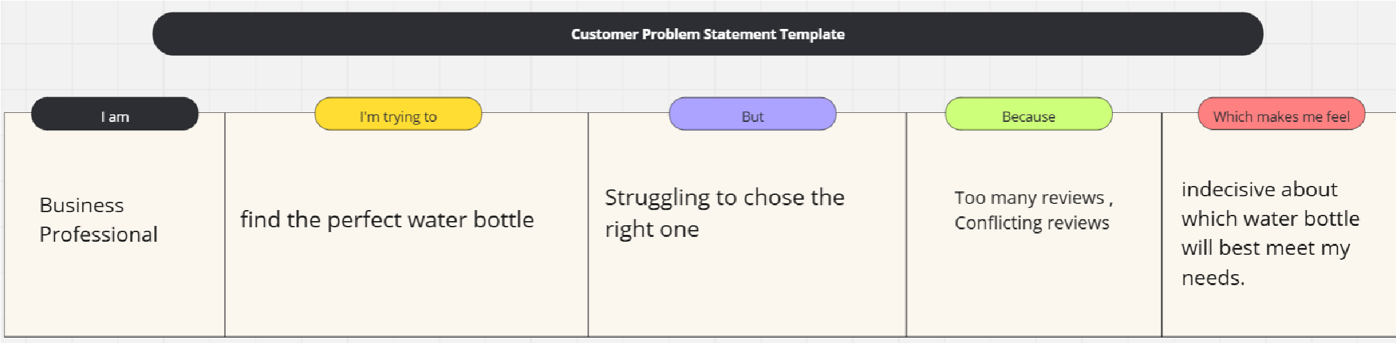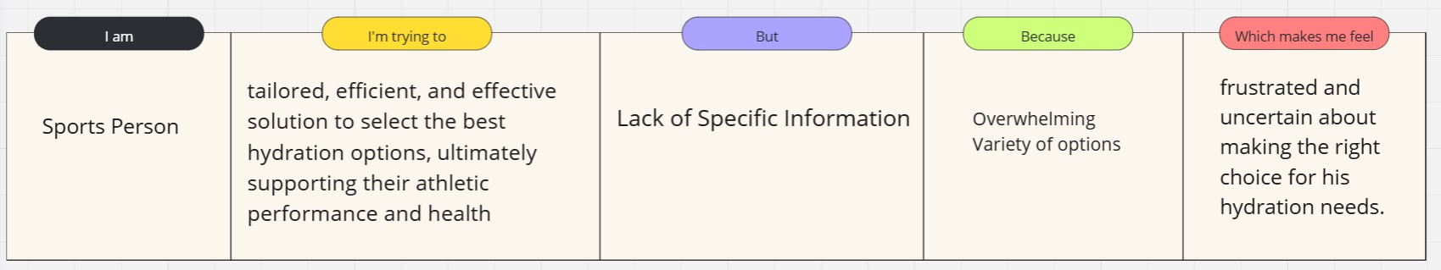

* Project Proposal (Proposed Solution)

Creating a website using CNN which predicts the flow of the water.

* Initial Project Planning

Initial Project Planning involves outlining key objectives, defining scope, and identifying stakeholders for a loan approval system. It encompasses setting timelines, allocating resources,

and determining the overall project strategy. During this phase, the team establishes a clear

understanding of the dataset, formulates goals for analysis, and plans the workflow for data

processing. Effective initial planning lays the foundation for a systematic and wellexecuted project, ensuring successful outcomes.

3. Data Collection and Preprocessing Phase

* Data Collection Plan and Raw Data Sources Identified Data quality is ensured through

thorough verification, addressing missing values, and maintaining adherence to ethical guidelines, establishing a reliable foundation for predictive modeling.

* Data Quality Report

Data quality is ensured through

thorough verification, addressing missing values, and maintaining adherence to ethical guidelines, establishing a reliable foundation for predictive modeling.

* Data Preprocessing

Data Exploration involves analyzing the loan applicant dataset to understand patterns,

distributions, and outliers. Preprocessing includes handling missing values, scaling, and encoding

categorical variables. These crucial steps enhance data quality, ensuring the reliability and effectiveness of subsequent analyses in the loan approval project.

4. Model Development Phase.

* Model Selection Report

It evaluates relevance, importance, and impact on predictive accuracy, ensuring the inclusion of key factors influencing the model's ability

* Initial Model Training Code, Model Validation and Evaluation Report

The Initial Model Training Code employs selected algorithms on the loan approval dataset,

setting the foundation for predictive modeling. The subsequent Model Validation and Evaluation

Report rigorously assesses model performance, employing metrics like accuracy and precision to ensure reliability and effectiveness in predicting loan outcomes.

5. Model Optimization and Tuning Phase

* Tuning Documentation

The Gradient Boosting model was selected for its superior performance, exhibiting high accuracy

during hyperparameter tuning. Its ability to handle complex relationships, minimize overfitting,

and optimize predictive accuracy aligns with project objectives, justifying its selection as the final model.

* Final Model Selection Justification

The Final Model Selection Justification articulates the rationale for choosing Gradient Boosting

as the ultimate model. Its exceptional accuracy, ability to handle complexity, and successful

hyperparameter tuning align with project objectives, ensuring optimal loan approval predictions

6. Results

• Output Screenshot

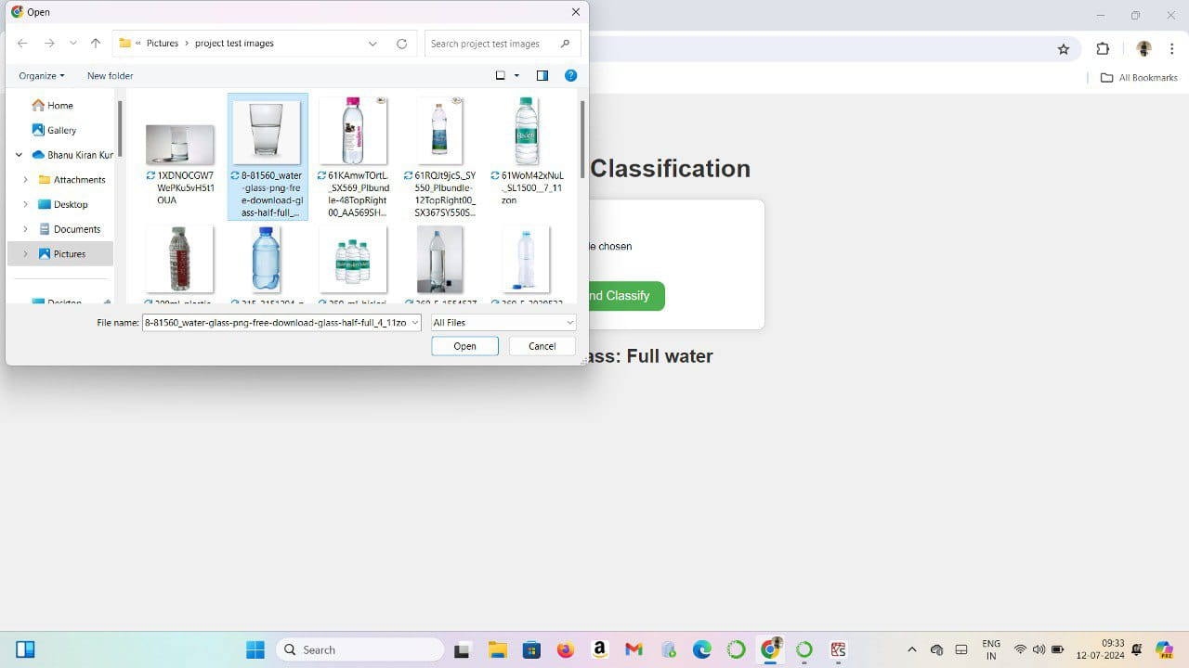

7. Advantages & Disadvantages

1. **User Convenience** 
   * **Easy Access to Information**: Users can easily find and compare different types of water bottles based on their preferences and needs.
   * **Streamlined Decision-Making**: Helps consumers make informed decisions quickly by providing detailed classifications and comparisons.
2. **Environmental Impact** 
   * **Promotes Recycling**: Educates users on the recyclability of different bottles, encouraging environmentally responsible behaviour.
   * **Reduces Waste**: By highlighting reusable and recyclable bottles, the site can help reduce the number of single-use bottles.

* 1. Conclusion the benefits of a water bottle classification website are compelling, careful planning, robust technical infrastructure, and strategic marketing are essential to overcoming the inherent challenges and achieving a successful, impactful platform. Balancing these factors will be key to creating a site that not only serves its users effectively but also contributes positively to environmental sustainability and business growth.

* 1. 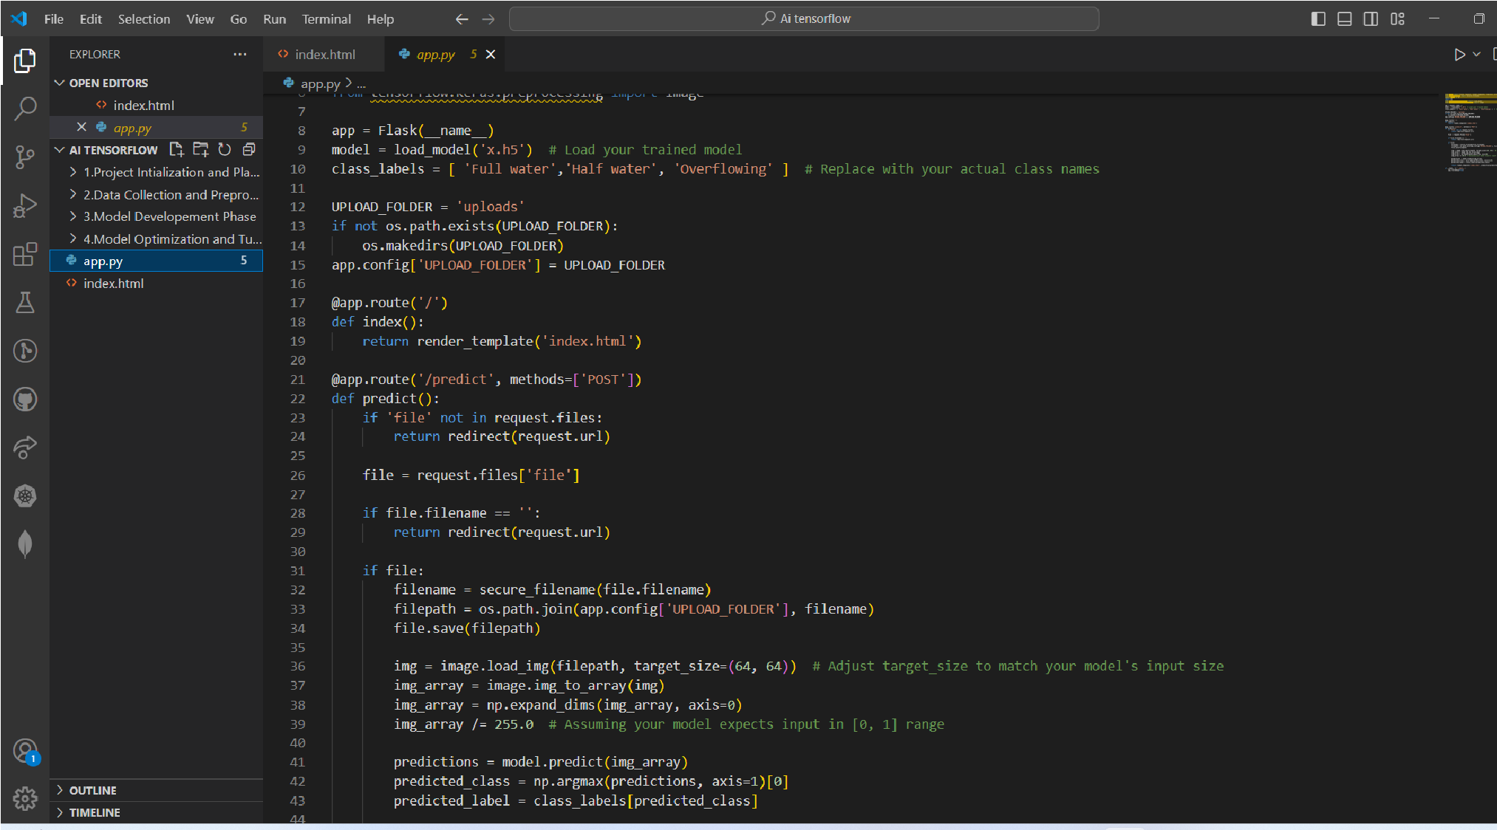Future Scope The future scope of a water bottle classification website is broad and promising, with numerous opportunities for growth, innovation, and expanded impact.
  2. Appendix
  + Source Code
  + GitHub & Project Demo Link

Github:<https://github.com/Harshithagubba/DeepLearning_project>

Project Demo : https://youtu.be/JPOV54bSkjE?si=DTbrumYnHC7lpziU